1. **What is SDLC?**

A software development lifecycle essentially series of the steps or phase that provide the model for the development and lifecycle management of application or software.

1. **What is software testing?**

Software testing is used to identifying completeness, correctness and quality of developed computer software/website or application.

1. **What is agile methodology?**

Agile methodology is combination of iterative & incremental model that focus on adaptability and customer satisfaction by rapid delivery of working software product.

1. **What is SRS?**

Software requirement specification is complete description of the behavior of the system to be developed.

1. **What is oops?**

It is a way of writing code in organized way.

1. **Write Basic Concepts of oops.**

Basic Concepts of oops is:

-Class

-Object

-Inheritance

-Abstraction

-Polymorphism

-Encapsulation

1. **What is object?**

Object gives permission to functionality of class.

1. **What is class?**

It is collection data member & member function.

1. **What is encapsulation?**

Wrapping data in single unit.

1. **What is inheritance?**

Deriving an attribute to other class.

1. **What is polymorphism?**

One name multiple form.

1. **Draw Usecase on online bill payment system (paytm).**

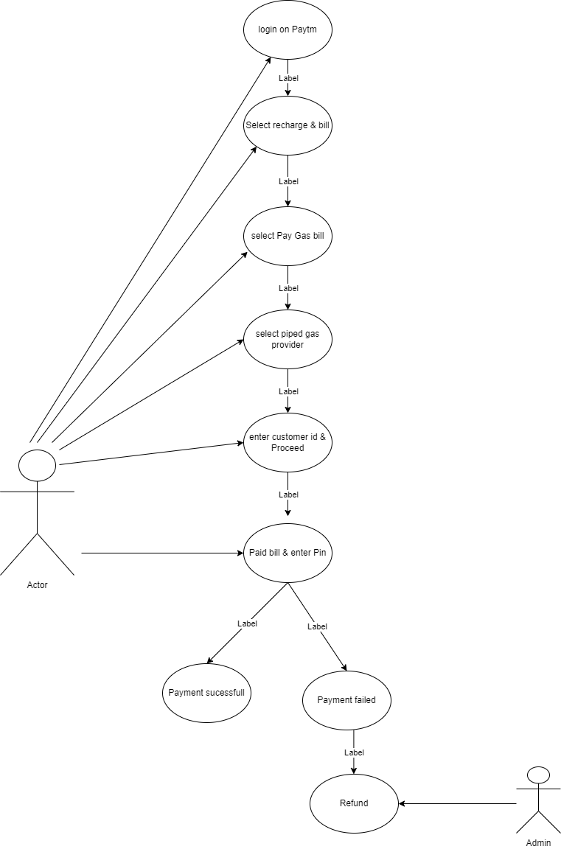

1. **Draw Usecase on banking system for customers.**

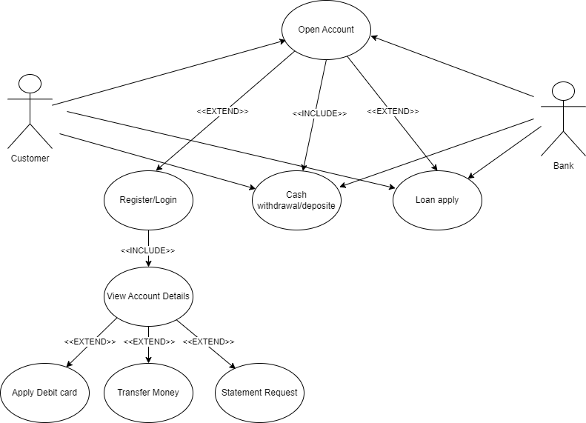

1. **Draw Usecase on Broadcasting System.**

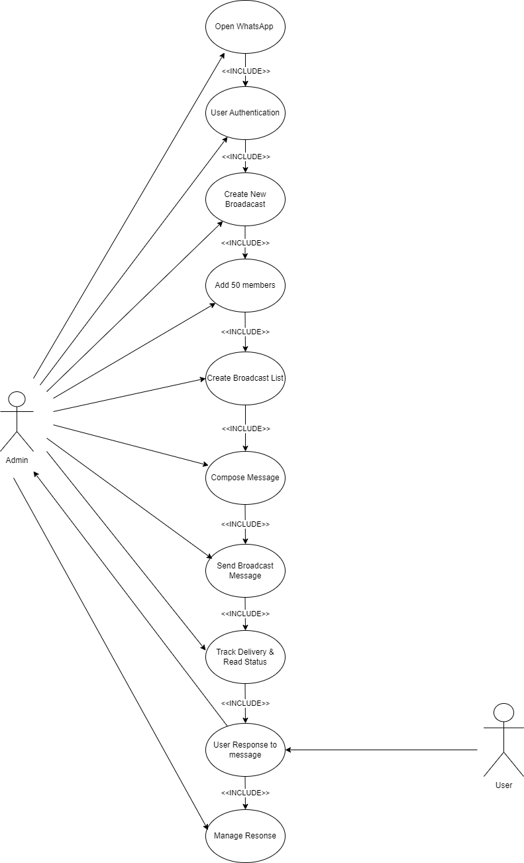

1. **Write SDLC phases with basic introduction**

1.Requirement collecting- collect requirement of customer

2.Analysis-Model and specify the requirement.

3.Design-Model and specify a solution

4.Implemention-construcion solution in software.

5.Testing-Validate the solution against requirement.

6.Maintence-Repair defects and adapt new requirement

1. **Explain Phases of the waterfall model**

1.Requirement collecting- collect requirement of customer

2.Analysis-Model and specify the requirement.

3.Design-Model and specify a solution

4.Implemention-construcion solution in software.

5.Testing-Validate the solution against requirement.

6.Maintence-Repair defects and adapt new requirement

1. **Write phases of spiral model**

-Planning

-Risk Analysis

-engineering

-customer evaluation

1. **Explain working methodology of agile model and also write pros and cons.**

Agile methodology is combination of iterative & incremental model that focus on adaptability and customer satisfaction by rapid delivery of working software product.

It is break the product in to small incremental build.

Pros:

-Suitable for fixed & changing requirement.

-little and not planning require.

-easy to manage.

Cons:

- Lack of Clear Documentation

- Not Suitable for Large projects

1. **Draw usecase on OTT Platform.**

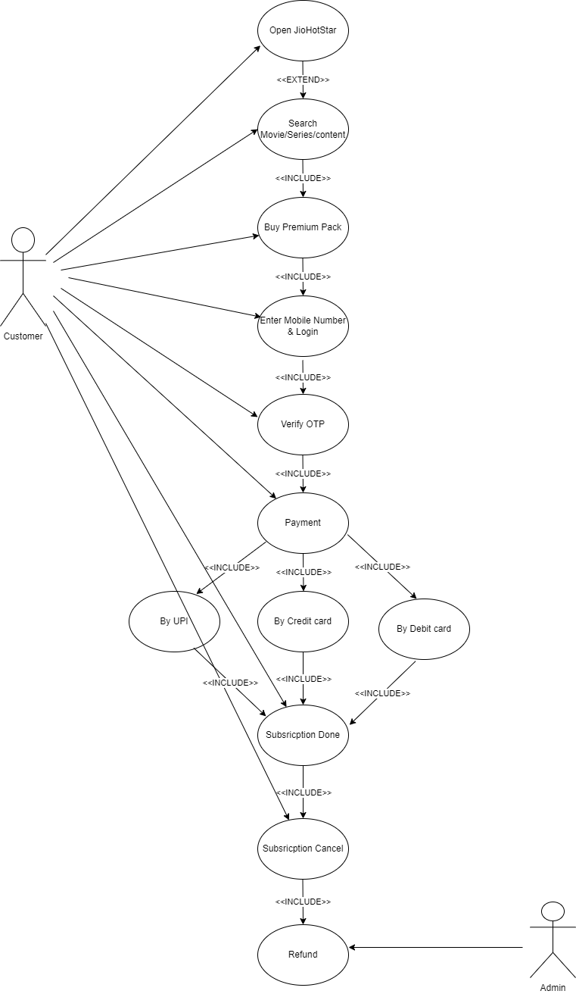

1. **Draw usecase on E-commerce application**

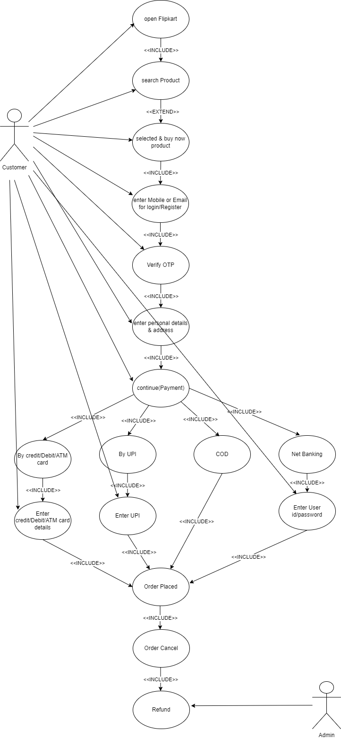

1. **Draw usecase on Online shopping product using payment gateway**.

